Assignment 3 -

Project Idea: To create a simple web application to track and add expenses
The expenses will cover rent, grocery, gas and shopping and more can be added
MongoDB will display the 4 that I added

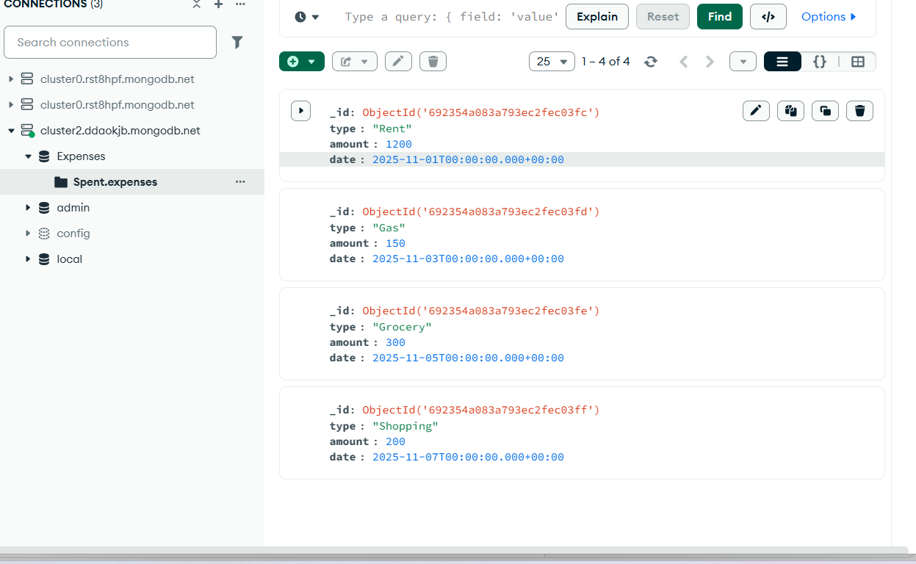

Users are able to change prices and can edit and delete expenses

